* **Name of the Activity:** A web-talk on “Covid-19: Senior Citizens, Please Stay Well”
* **Type of the Activity**: Seminar
* **Organizing Department**: Seminar sub-committee, Chakdaha College
* **Date and time of the Activity**: 25.06.2020 from 13.30 pm – 15.30 pm
* **Speakers**: Dr. Dhires Chowdhury, Geriatrician, Social Activist & Poet
* **Outcome:** Amid the Covid-19 pandemic, the elderly population, who predominantly found themselves confined at home due to lockdown measures, experienced various forms of anxiety. This empowering and enlightening webinar aimed to bolster the mental resilience of older individuals. Dr. Chowdhury's address focused on strategies for overcoming anxiety.
* **Photograph of the Programme:**

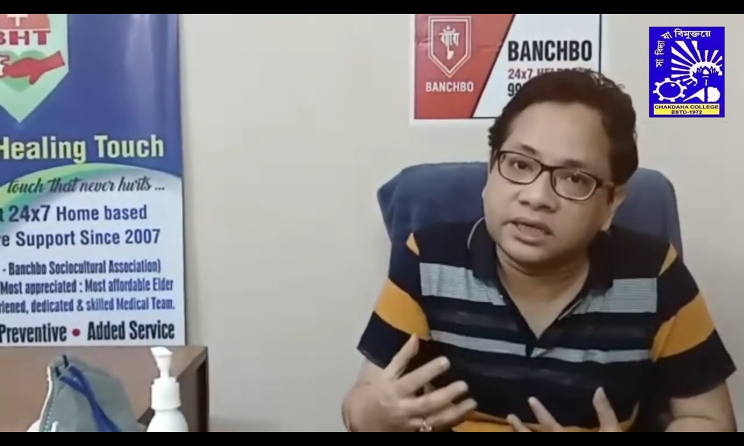

**Link of the Programme:** [**https://youtu.be/snFQdq6TEXE**](https://youtu.be/snFQdq6TEXE)**, No of views: 33**